Peptides generate a distinct signal in the mass spectrum. Low charge species generate a series of distinct peaks. The expected ratio of the peak heights can be approximated by insilico analysis of peptide sequences [GAY] or by using a Poisson distribution.

Figure 1 is a spectrum from a 2 charge peptide. A simple algorithm to identify the feature might proceed as follows. Reduce the data from the nearly continuous raw spectrum to a set of individual peaks (mz and intensity value pairs). Figure 2 shows the peaks identified by smoothing the data and reporting local maxima.

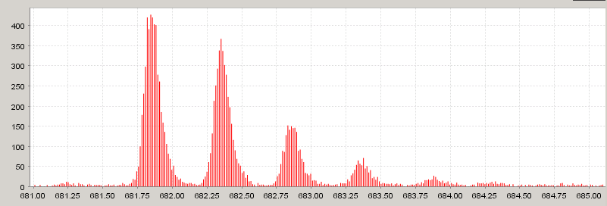
Figure 1

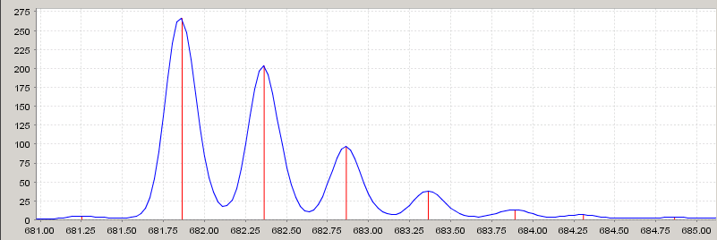
Figure 2

Table 1
681.86 | 266 | 100%
682.36 | 203 | 76%
682.86 | 97 | 36%
683.36 | 38 | 14%
683.89 | 13 | 5%
684.30 | 7 | 3%

Table 1 shows the reported peaks. We find the peaks evenly spaced at 0.5Da intervals, and closely fitting the expected peak height ratios. With this information we can confidently report that we have found a doubly charged peptide with a mono-isotopic mass of 1361.72Da (=2*(681.86Da-1Da)).
ESTIMATED RATIOS

Signals like this prove to be relatively easy to analyze. A typical algorithm to find peptides in a scan might proceed like this REFERENCES
Preprocess the data
Remove noise, perhaps using Gaussian filter or other smoothing method
Threshold the data to remove small peaks and remove background
Those two steps might also be accomplished using wavelet thresholding
Identify peaks (or centroid the data)
Starting with the largest peaks identify patterns consistent with a peptide signature
Filter identified peptides using a quality criteria
Combine peptides that are discovered in multiple charge states

In the LC-ESI setup typical of our experimental design, we may have thousands of spectrum recorded at short intervals. A typical peptide would elute of a span of time comprising several spectra. Therefore, a second pass is required to combine the peptide features that are discovered in several adjacent (or mostly adjacent) spectra.

Problems
Several confounding problems can occur in this data, especially in data generated from complex samples such as serum.

Increased noise
High background signal
Proximate or overlapping features
Chemical noise (real, but not relevant signals)

The basic setup of the LC-ESI experiment contributes to this problem. The peptide is profiled by many spectra as it elutes. However, at the beginning and end of that elution period the signal may be quite weak, effectively contributing noise to those spectra. Also, the longer the elution period the more likely it will overlap another peptide. This may confound evaluation even further.

We can maintain high confidence in our identifications by maintaining a reasonably high minimum signal-to-noise ratio. However, the experimental conditions are such that the interesting features are likely to be quite small. The major problem we face is identifying small features with high confidence.

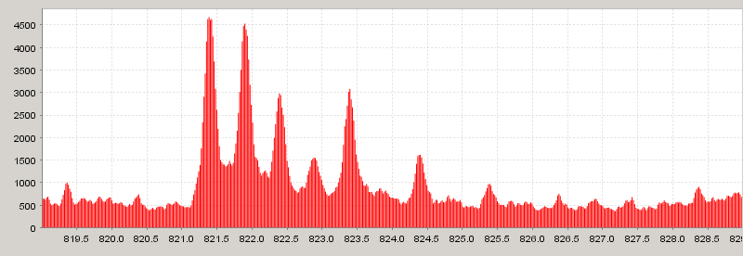
Feature A
Feature B
Figure 3

Figure 3 illustrates several of these points. First notice that we have a noisy background consists of peak of various heights above a fairly high “base”. On top of this we add a signal from two overlapping peptides. Feature A is a doubly charged peptide whose first peak is at 821.4Da. The next three peaks are spaced evenly at 0.5Da intervals. Feature B is singly charged with its first peak at 823.4Da. This feature has only two features that clearly stand out from the background. In addition, the first peak of feature B lands exactly where we expect to find the fifth peak of feature A. It presents a problem when identifying the peaks that comprise feature A to recognize that the peak encoutered at 823.4Da may start a new feature and should not be subsumed (and likewise for the subsequent peaks of Feature B).

This might seem like the “perfect storm” for the peptide identifier. It represents a) coeluting peptides b) overlapping m/z ranges (each feature being say 4Da wide) and c) peaks that exactly align. The likelyhood of finding examples of the first two problems depends directly on the complexity of the mixture. Unfortunately, given two coeluting, overlapping peptides the chance that the peaks align is very high. This is due to the tendency of peptides to differ by nearly even multiples of 1Da. [GAY other references]

Highly charged ions presented another problem. The distance between isotopic peaks shrinks as the charge state increases (as 1Da/charge). When the peaks distance is less than the typical peak generated by the machine in use, accurate peak extraction gets difficult.
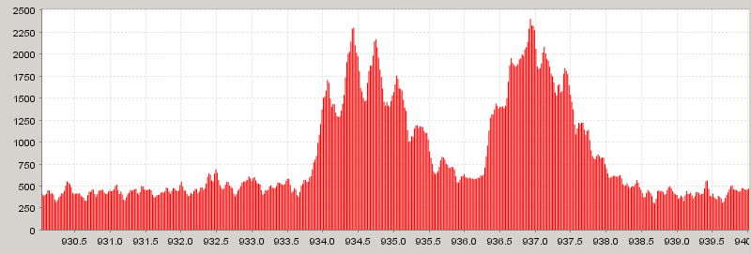
Figure 4

Figure 4 shows a three charge peptide with fairly distinct peaks, but you can see that the troughs in the signal do not approach zero. The second peptide is four-charge ion and does not present clear peaks. Using our simple smooth/local maxima algorithm tends to perform poorly on these features.

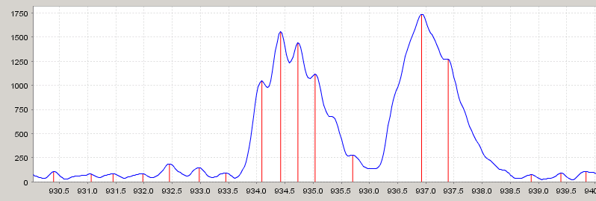
Figure 5

You can fiddle with the smoothing algorithm a little to adjust the sensitivity. However the fundamental problem is the use of local maxima to locate the peak. This approach does a poor job of recognizing “shoulders” such as the peak at 936.5.

Improvements to the basic algorithm
From our initial implementation of the algorithm described above, we’ve focused on two main areas to improve our detection accuracy. We tried to improve our peak detection within an individual spectrum. In addition we tried to use the information provided by the elution profile or time dimension of the data.

Peak detection
Even after noise and background removal we were not satisfied with our peak detection ability. The example above is a typical problem. Working with Tim Randolph we decided to use a simple wavelet analysis to improve our peak detection. HELP TIM. We generate a set of vectors using a wavelet multi resolution analysis transform (R reference). We choose a level of the wavelet transform that best matches the width of the peak features generated by the target machine. This basically corresponds to the negative of the second derivative of the original signal at the chosen scale. Here is the signal we generate for this analysis.

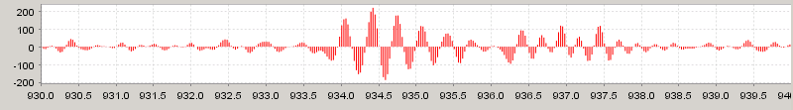
Figure 6

From this signal we not select local maxima to select peak locations. Thus we select peaks based on the local maximal concavity in the original signal. This only gives us the location of the peaks; we estimate peak height by using a very lightly smoothed version of the original signal.

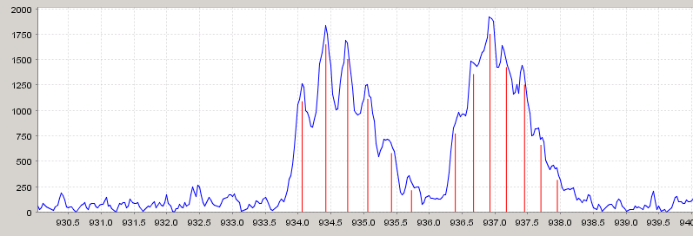
Figure 7

You will notice that the baseline of signal in figure 7 is lower than in the original signal in figure 4. Early on in the processing we compute a sort of “running minima” for the signal and subtract it. This helps give numbers that meaningfully represent the relative heights of the detected peaks. For instance, when we accidentally report a noise peak as real, we’d rather report it’s height above the background (hopefully small) rather than the height including background which might be comparatively large.

Elution profile
All the processing that we’ve discussed so far ignores the two dimensional aspect of the data. Since the solution being profiled changes slowly compared to the sampling rate of the machine, successive scans are fairly similar. Viewed as a two dimensional image, the signal looks very much like a gel separation. Figure 8 shows a very small window of a typical run. This window is 10Da tall and 80 scans wide. Each individual island represents a single isotopic variant of a particular peptide. The vertical island chains are the represent the characteristic mass spectrum signal of a single peptide species. In this example we see perhaps four peptides draw boxes

The graph shows a series of readings over time for a specific m/z value, this is what we call an elution profile.

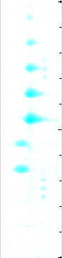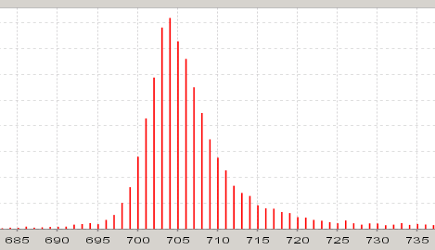
Figure 8

While the width of this elution profile contributes to overlapping signals and other problems, it also contributes a signature we can look for. For any given potential peak we find in a spectrum, the presence of a clear elution profile over time gives up high confidence that the peak is not noise. We can fashion an extremely strong noise filter by taking advantage of the fact that the data we are analyzing is over sampled in both axes. Peptides are detected over several spectra, and peaks are represented by many points in the spectrum. Not only do we expect to find the elution profile at the m/z value that we choose as our peak location, we expect to see it across all the nearby m/z values as well. Likewise, for any peak we detect we expect to see it across several scans. Below, we will discuss how this is incorporated into our final algorithm.

We can take advantage of the two dimensionality of the data to help with the overlap problem as well. Even though the profiles of the two features may overlap, they may have different characteristic shapes. In Figure 8, the two strong features have a fairly wide area of overlap. If we can characterize the shape and location of each feature, we can separate or cluster the individual peaks before trying to resolve them into peptide features. This allows us to crudely do in code, what our eyes do easily. In practice we are only using the maxima, but I hope to improve this. This approach has another side effect as well. By extracting peaks from the two dimensional data, we tend to extract peaks where they are at their most intense. This reduces mistakes we make when trying to analyze peaks generated at the edges of an elution profile, where the signal-to-noise ratio may be low.

Algorithm
In the end there is a lot of information that can be gathered about each point in this very large source dataset. As each idea was worked on and developed separately we ended up with a bit of hybrid algorithm. Of course, improving and streamlining this is ongoing work. I believe the end results show that even in its current state the information we gain from using 2d analysis is extremely valuable. Since the dataset is quite large, it is broken up into windows that can fit into main memory. Then each window is processes as follows.

Prepare the data
Remove background and streaks
Gross features
For each row in the image (corresponding to mz value) use simple edge detection algorithm to look for sharp rises in intensity indicating the start of an elution profile.
For spectrum look for sharp rises in intensity indicating the presence of a large peak.
Where we find a many edges that line up, we have a gross feature.
Remember these gross features.
This algorithm is very sensitive to the presence of elution profiles, while being very good at ignoring noise. It is not very good at precisely locating peaks.

Peaks
Process each spectrum looking for peaks.
Where we find a peak that corresponds to a maximum in an elution profile, record a peak.
Remember these peaks.
This algorithm gives us very good peaks locations, but also tends to give us a LOT of noise.

Combine
Throw out all the peaks that are not near a gross feature. The algorithm could probably be improved by integrating these steps, but it seems to give us nearly all the benefit we hoped we would get based on the discussion above.

Extract features
This is the same as before, starting at the highest peak look for collections of peaks that fit an expected peptide profile.

IMAGE

Further work

Integrate gross feature/peak detection.

Optimizing feature extractor. Consider features in sets instead of one at a time (greedy algorithm). For instance, might improve case where peaks from two peptides align exactly.

